MyCommercialAD.com Progress Report

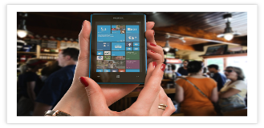

|  |  |  |  |  |  |
| --- | --- | --- | --- | --- | --- |
| **Status Report Date:** | | | 2019-09-10 | | |
| **Project team members:** | | | Clarence Mitchell | | |
| **Advisor name:** | | | Dr. Eric Tao | | |
| **Client/Sponsor name (if applicable):** | | | N/A | | |
| **Status Period:** | **From:** | September 18, 2019 | | **To:** | September 24, 2019 |

Cost performance [cost variance] % under/over estimated hours

Schedule performance [schedule variance] % ahead/behind schedule

|  |  |
| --- | --- |
|  | $ or #of hours |
| Planned hours to date | 96Hours |
| Actual hours to date | 126 Hours |
| Approved total project hours | 288 Hours |
| Estimated total hours at completion | 310 Hours |

Issues requiring advisor/client attention

None.

2

Changes to scope, schedule, hours during this period

1 None

2

Major problems encountered and planned action to resolve

1 None

Issues identified this period and required action

1 correcting issues from Google disabling API

2

Major accomplishments in the past period

1 Completed 2nd iteration user story selection and requirements

2 Started coding on 2nd iteration

Client feedback from this week (if applicable)

1 N/a

2